**Medha KARRI – WORK SAMPLES**

[karri.15@wright.edu](mailto:karri.15@wright.edu) · <https://www.linkedin.com/in/medhachaitanya/>

Below are some of my hobby projects built in my free time.

Apart from my primary skills (JS, HTML5, Workday integrations, Workday Studio, SAP FIORI) as listed in the resume, below are few projects that showcase my strong secondary skills in C#, XAML, JSON, XML, UI Designing, Integration with third party libraries like Telerik, SQLite Databases, Product UX Design and responsive app development skills.

I have experience in both Web and Desktop development.

**Pure Battery Analytics:**

One of the best rated and top free apps for Windows 10 in Microsoft Store.

Features: Battery Analytics and life estimates, background services, notifications and alerts, system information, settings and battery optimizations.

Technologies Used: MVC, Windows Universal SDK, C#, SQLite, XAML, Telerik UI libraries.

**URL:** [**https://bit.ly/2KKHPwH**](https://bit.ly/2KKHPwH)

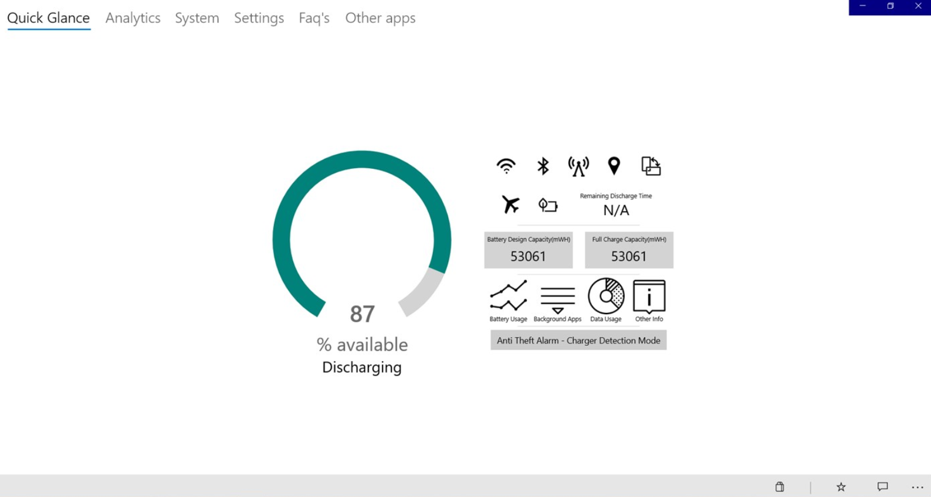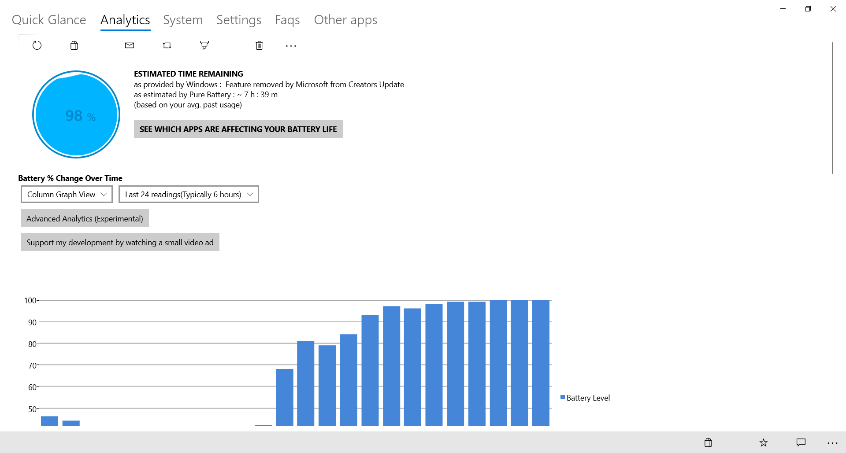

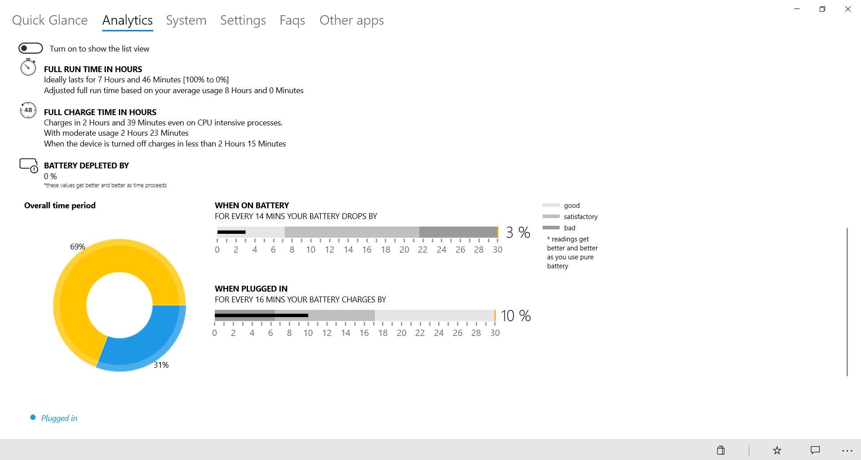

**PTO**

**Simple Math Under Pressure**

My first game using Microsoft Blend Animations and C# Xaml.

[**https://www.microsoft.com/en-in/p/simple-maths-under-pressure/9nblgggzngvw?activetab=pivot:overviewtab**](https://www.microsoft.com/en-in/p/simple-maths-under-pressure/9nblgggzngvw?activetab=pivot:overviewtab)

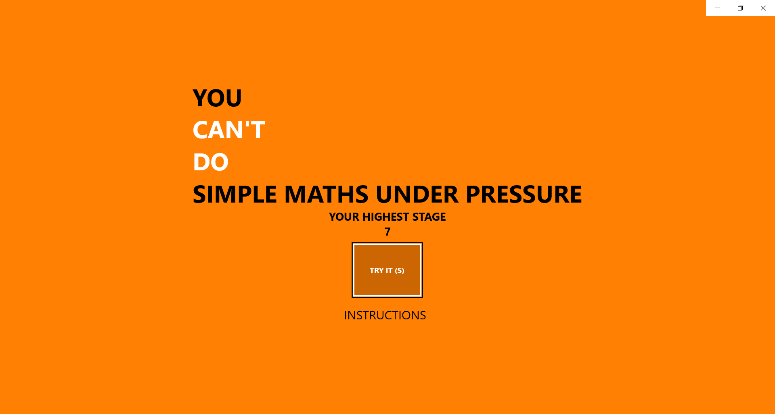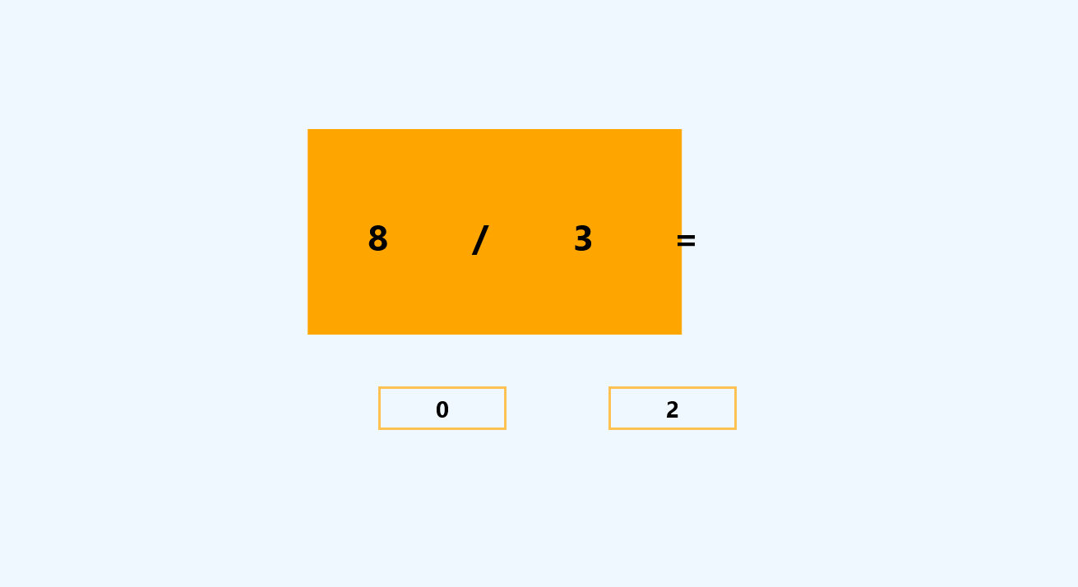

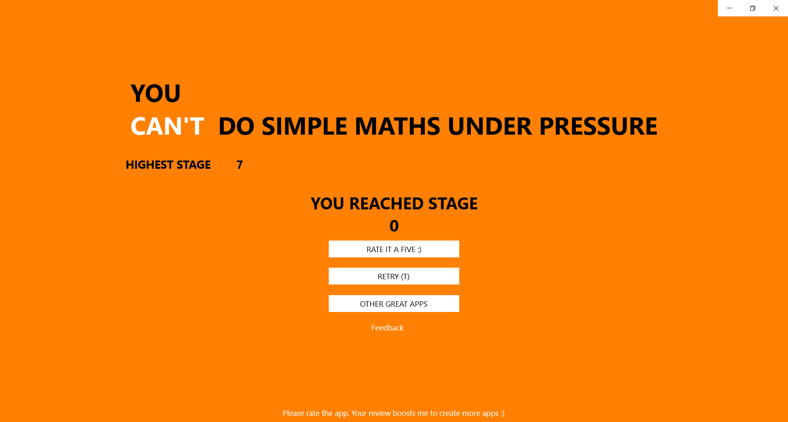

**PTO**

**Secure Folder, Files and Encrypt**

This is an application that can protect, hide and encrypt and decrypt your files and folders. This app is made for Windows 10 Desktop.

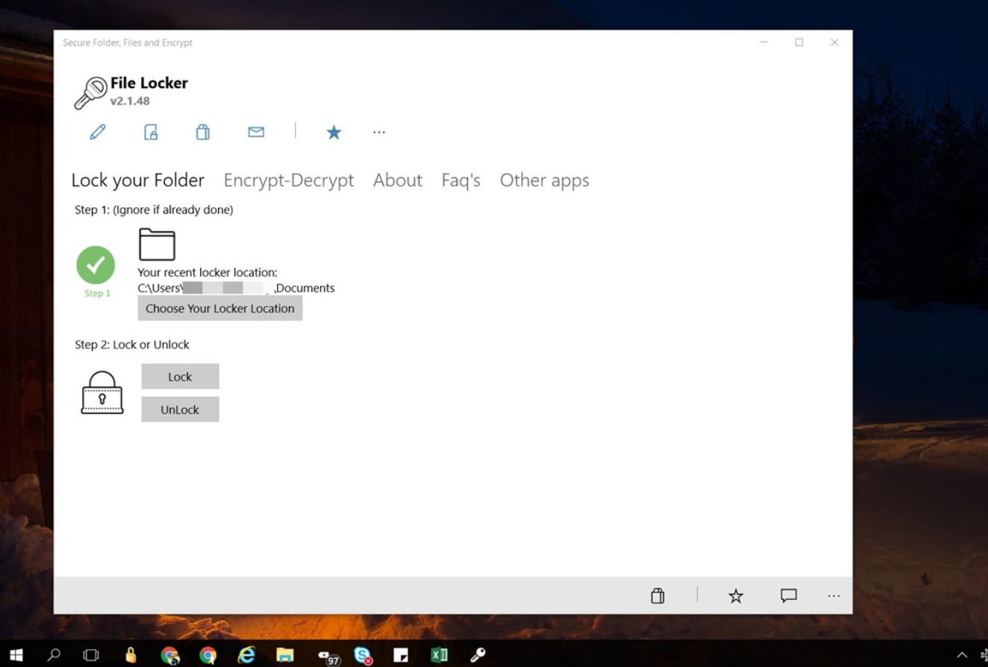

**Battery Percentage System-Tray**

This is a handy application made for Windows based systems that will show the current battery percentage in the system tray like that of Android devices. This app is distributed as an add-on using **ClickOnce** **Setup** file and is implemented in C#, XML, WinForms.

Project download URL: <https://github.com/medhachaitanya/PureBatteryAddOnSetup>

Sample screenshot of the application running in the system-tray.



Sample screenshot of the application settings.

